The Stoney Lake weekend is at Pine Vista, an award winning 4 star resort in the beautiful Kawartha Lakes, a 45-minute drive north of Peterborough, Ontario. Dancing at nearby USLA Sunset Pavilion, 2378 Crowe’s Landing Road.

Come and join us for this relaxing, fun weekend of Scottish country dancing and socializing. All levels of dancing experience are welcome at the weekend.

Happenings 2024

FRIDAY

3:00- 6:00 Pine Vista Check in ♦
7:30- 9:30 Dancing at Sunset Pavilion
10:00-11:00 Ceilidh at Pine Vista

SATURDAY

9:00-12:30 Workshop at Sunset Pavilion
12:30- 1:30 Lunch at Sunset Pavilion
2:00- 3:30 Ball practice at Sunset Pavilion
5:00- 6:30 Dinner at Hobarts Lighthouse
2281 McCracken’s Landing Rd
7:30-10:00 Ball at Sunset Pavilion
10:30-11:30 Social at Pine Vista

SUNDAY

10:00-11.00 Dancing at Pine Vista or Pavilion
11:30 BBQ Lunch

♦ Please inform the Resort if you will be arriving after 7:00 pm

Saturday Night Ball Programme

Kendall’s Hornpipe 6x32J 2C4CSet Graded
Happy Returns 8x32R 3C4CSet MMM2
Spirit of the Dance 8x32S 3C4CSet TAC 50th
Teacher's Choice
Calm Before the Storm 8x32R 3C4CSet I. Boyd

BREAK

Toast to the Mousies 8x32J 3C4CSet RSCDS Bk 53
A Summer Meeting 3x32S 3CSet RSCDS Bk 48
Waverley 8x48J 3C4CSet RSCDS Bk. 15
Teacher's Choice
Polharrow Burn 5x32R 5CSet Foss Glendarroch

BREAK

Chased Lovers 8x32J 3C4CSet RSCDS Bk. 53
The Robertson Rant 4x40S 4CSet Sq RSCDS Bk.39
J.B. Milne 8x32R 3C4CSet H. Foss Fitchett

Extra

Pelorus Jack 8x32J 3C4CSet RSCDS Bk 41

WALTZ

*Dances will be briefed with one walk-through.

ACCOMMODATION & PRICES on separate registration form

Please join us for
Scottish Country Dance Weekend
at Stoney Lake
May 24-26, 2024

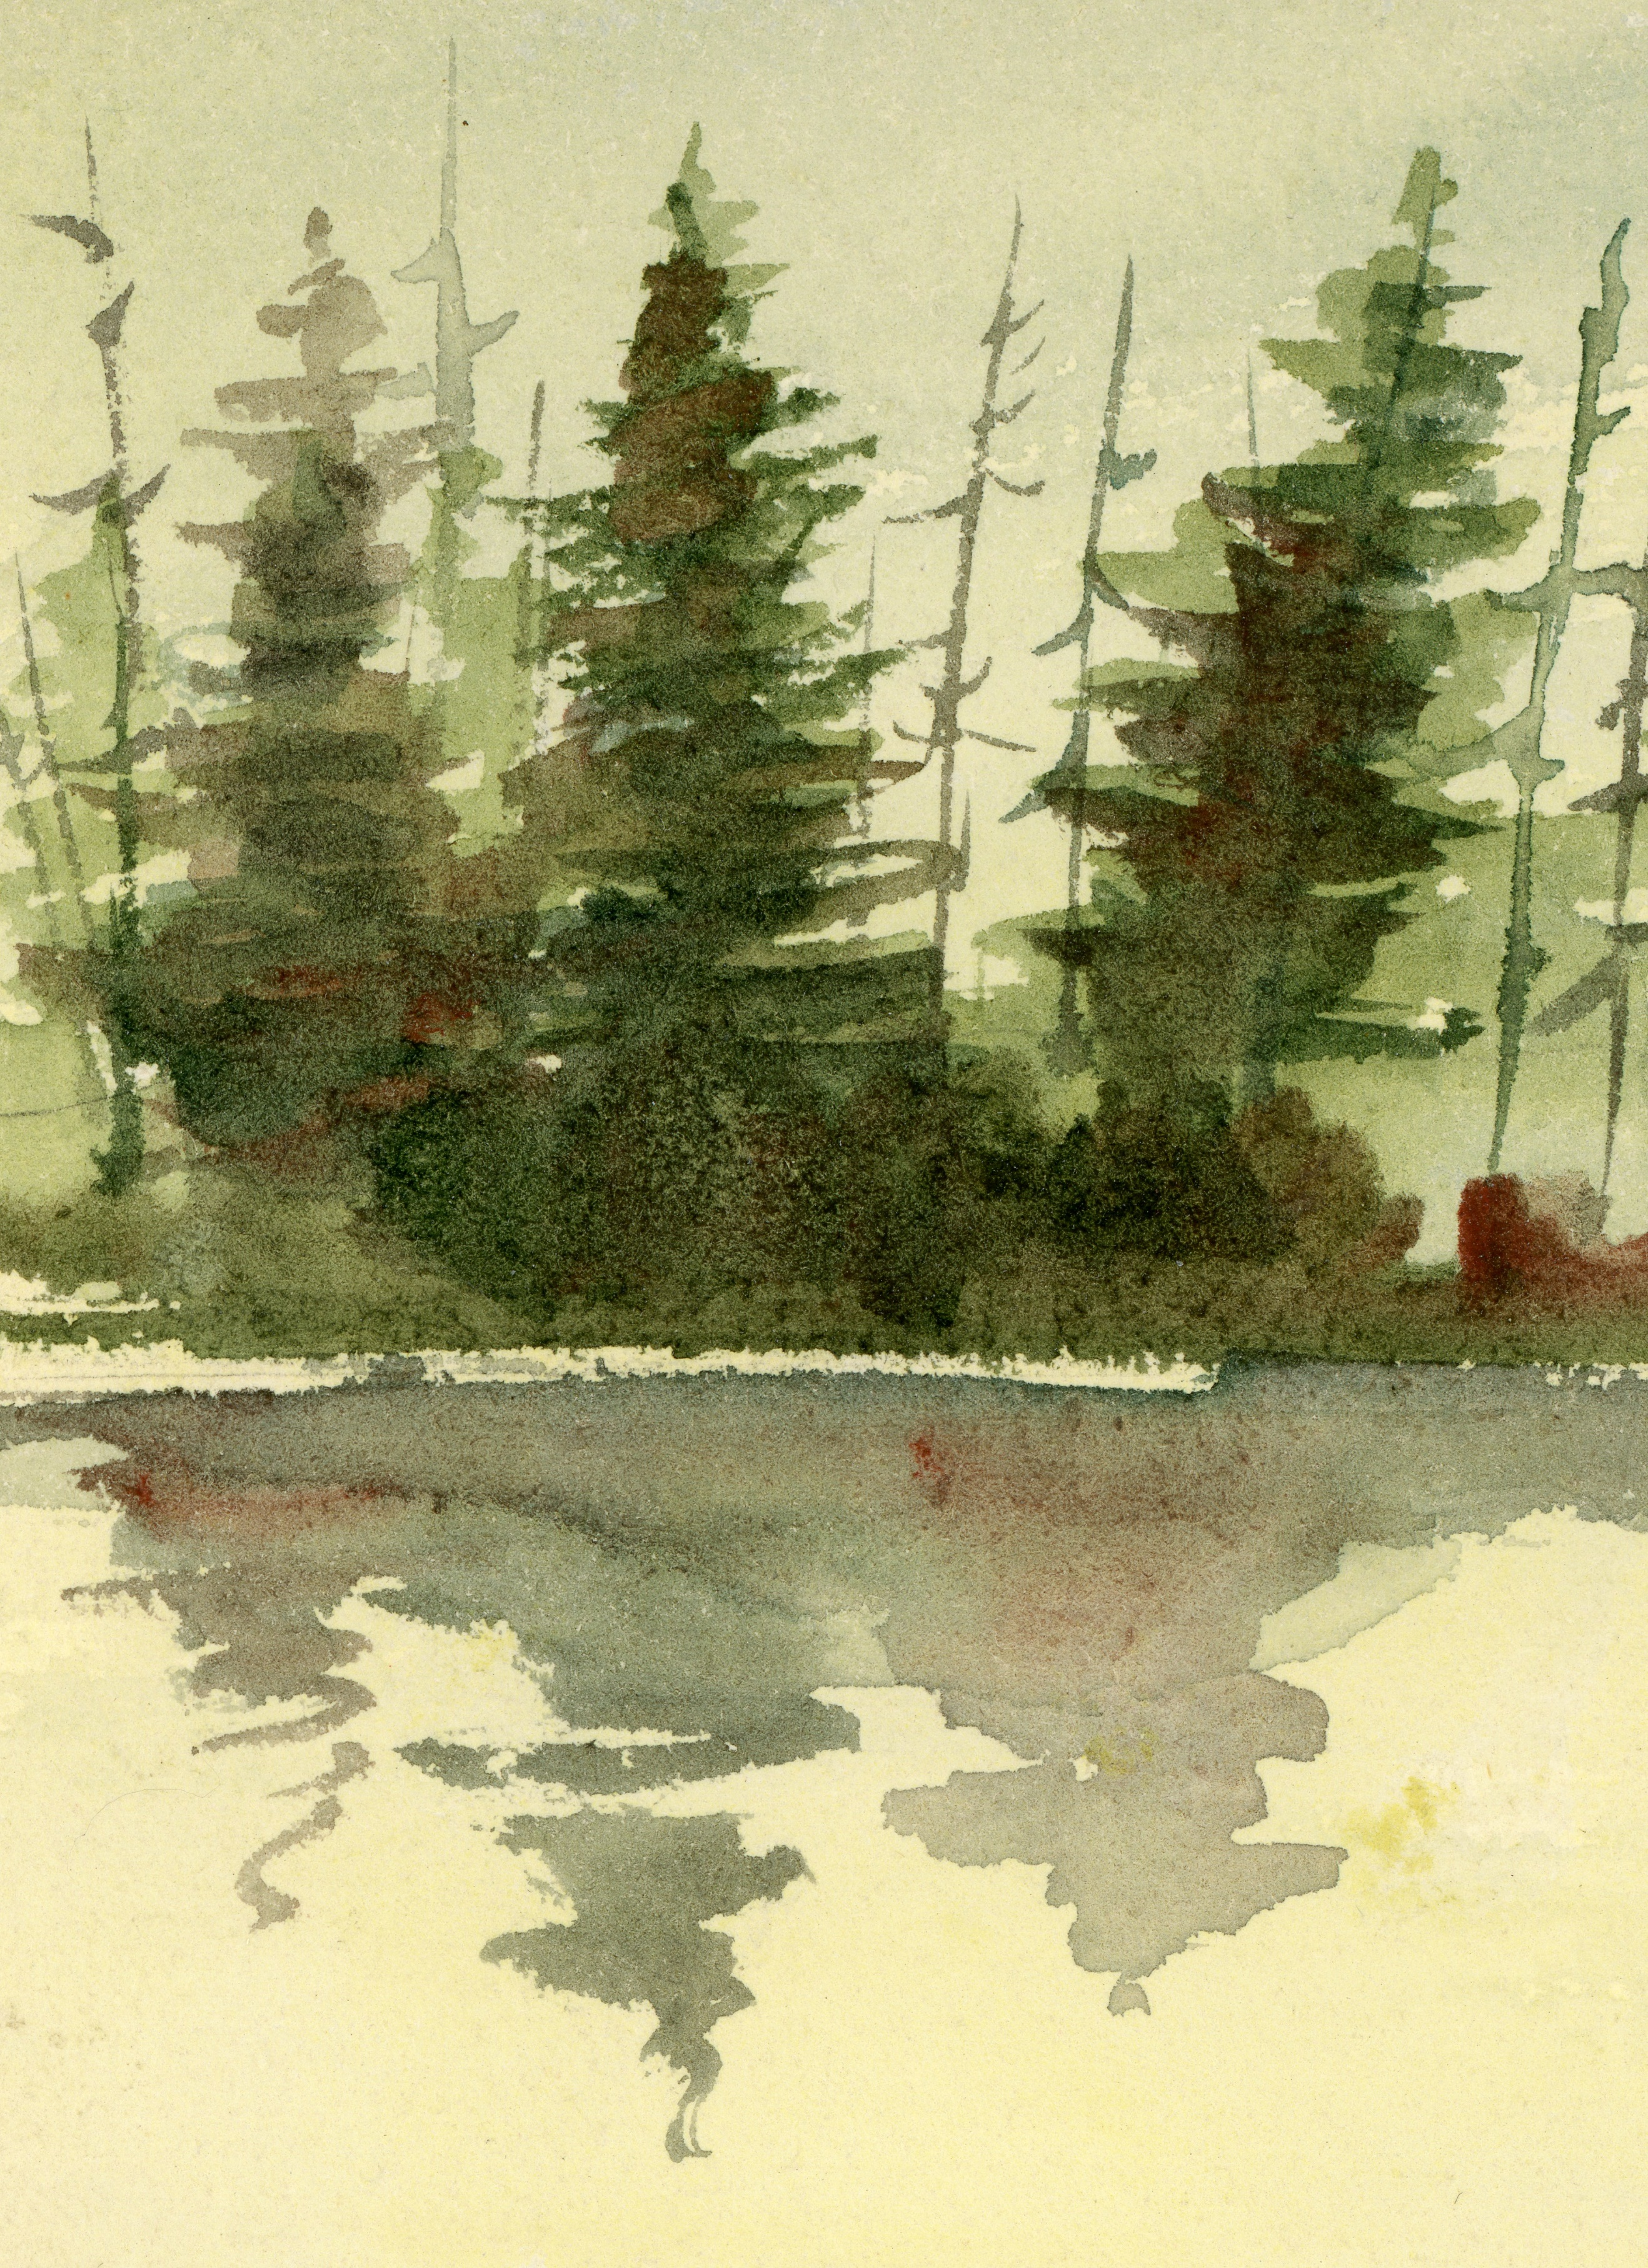

Guest teacher: Arlene Koteff
Musicians: Don Bartlett
And Blair Mackenzie
To book accommodation - Telephone Pine Vista Resort
1-800-634-2848 or 705-877-2108
Email: info@pinevista.com
Pine Vista, 932 Gilchrist Bay Rd.,
Douro / Dummer ON
Canada K0L 2H0
To register for the Workshop or Ball - Complete the registration form and mail or email to:
Kathy Armstrong
2 Cedar Point Road
Cameron, ON K0M 1G0
kathyarmstrong@xplornet.com

For more information please contact Kathy Armstrong
705-887-9755 or visit www.pscds.ca

Pine Vista

Vista Vista
Stoney Lake
County Rd 6
Hwy
28
Lakefield
Peterborough
Norwood
Hwy 7
County
Rd 40

Hastings
Cobourg
Port Hope
Hwy 401
Hwy
115
Hwy
28
Hwy
45
County Rd 29
29

